 | 7.1.6 Editors - 3D Viewport - Header - Add Menu
Table of content
Add Menu 3
Mesh 3
Plane 4
Last Operator Add Plane Panel 4
Cube 4
Last Operator Add Cube Panel 4
Circle 4
Last Operator Add Circle Panel 4
UV Sphere 5
Last Operator Add UV Sphere Panel 5
Ico Sphere 5
Last Operator Add Ico Sphere Panel 5
Cylinder 6
Last Operator Add Circle Panel 6
Cone 6
Last Operator Add Cone Panel 6
Torus 7
Last Operator Add Torus Panel 7
Grid 7
Last Operator Add Grid Panel 7
Monkey 8
Last Operator Add Monkey Panel 8
Curve 8
Bezier 8
Circle 8
Nurbs Curve 8
Nurbs Circle 8
Path 9
Last Operator Add Curve 9
Surface 9
Surface Curve 9
Surface Circle 9
Surface Surface 9
Surface Cylinder 9
Surface Sphere 9
Surface Torus 10
Last Operator Add Surface 10
Metaball 10
Ball 10
Capsule 10
Plane 10
Ellipsoid 10
Cube 10
Last Operator Add Meta ball 10
Text 11
Objects as Fonts 11
Editing Text 11
Inserting Text 12
Accent Characters 12
Last Operator Add Text 13
Last Operator Move Cursor 13
Type 13
Point Cloud 14
Last Operator Add Point Cloud 14
Align 14
Location X Y Z 14
Rotation X Y Z 14
Volume 14
Import OpenVDB 14
Empty 14
Last Operator Add Volume 15
Align 15
Location X Y Z 15
Rotation X Y Z 15
Grease Pencil 15
Blank 15
Stroke 15
Monkey 16
Scene Line Art 16
Collection Line Art 16
Object Line Art 16
Last Operator Add Grease Pencil 16
In Front 17
Stroke Depth Order 17
Armature 17
Last Operator Add Armature 17
Lattice 18
Usage 18
Last Operator Add Lattice object 18
Empty 18
Last Operator Add Empty 19
Image 19
Reference 19
Background 20
Speaker 20
Last Operator Add Speaker 20
Camera 21
Last Operator Add Camera 21
Light 21
Point 21
Sun 21
Spot 21
Area 21
Last Operator Add Light 21
Light Probe 22
Reflection Cubemap 22
Reflection Plane 22
Irradiance Volume 22
Last Operator Add Light Probe 22
Force Field 23
Last Operator Add Effector 23
Collection Instance 23
Last Operator Add Collection Instance 24
Create Isocam 24
True Isocam 24
Game Isocam 24
GameIso4to3cam 25
Ground plane 25

Add Menu
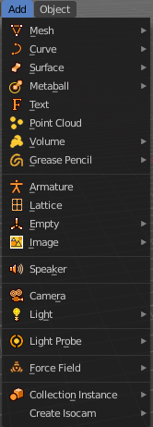
The Add menu contains everything that can be added to the scene. Geometry, camera, lights and so on.
When you create a primitive then the Adjust Last Operator Panel down left shows some settings for this primitive.

Note that the adjust last operator panel does not show when you add a primitive from the toolbar at the top. Then you have to open the adjust last operation panel from the toolbar.
Note also that those settings are not longer available when you perform any operation at the object. And be it to move the primitive. Some of those settings might still be available in the Properties editor. But things like create UV not. So when you want to adjust those settings, then do it immediately after creation.
Several object types can be edited. A Mesh Primitive for example. They have different modes available then. Some not. Like an Empty. There is just the Object mode available for an Empty.

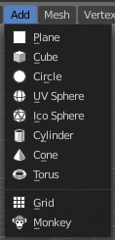
You can add some primitives in edit mode too. In object mode you have the whole range available. In Edit mode you usually just have the object type available with which you are in edit mode.
For example, when you are in edit mode with a mesh, then the add menu just shows the mesh content. When you add geometry in edit mode, then the added geometry becomes part of the current object.

Mesh
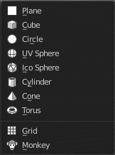
The Mesh section contains the primitives that are made of meshes.
Mesh objects are geometrical objects made of vertices, edges and faces. The geometry can be edited in various ways in edit mode. They can be sculpted in sculpt mode. The vertices can be painted in vertex paint mode. They can be used as a skin for a skeleton, and you can weight paint them so that it deforms with the armature. And you can add textures by UV mapping.

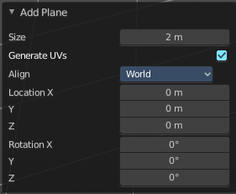
Plane
Plane creates a simple quad face mesh.

Last Operator Add Plane Panel
Size is in real the size of the plane.
Generate UV's creates UV's for this primitive.
Align aligns the geometry to the chosen view. World, View or 3D cursor.
Location Adjust the location of the Plane.
Rotation defines the rotation of the Plane.

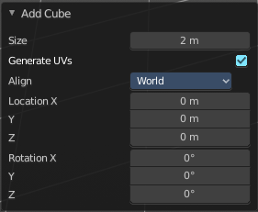
Cube
Cube creates a Cube mesh.

Last Operator Add Cube Panel
Size is in real the size of the Cube.
Generate UV's creates UV's for this primitive.
Align to view aligns the geometry to the chosen view. World, View or 3D cursor.
Note that this option is dysfunctional when you call the Adjust Last Operator panel from the Toolbar editor.
Location defines the location of the Cube.
Rotation defines the rotation of the Cube.

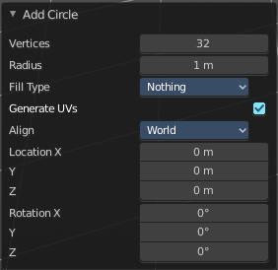
Circle
Circle creates a Circle mesh.

Last Operator Add Circle Panel
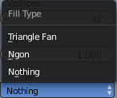
Vertices defines of how much vertices the circle is made.
Radius defines the radius of the circle.
Fill Type defines how the Circle mesh is filled.
- Nothing means you have pure edge geometry.
- N-Gon means that the circle face is a N-Gon face.
- Triangle Fan means that the circle face is triangulated.
Generate UV's creates UV's for this primitive.
Align to view aligns the geometry to the chosen view. World, View or 3D cursor.
Note that this option is dysfunctional when you call the Adjust Last Operator panel from the Toolbar editor.
Location defines the location of the Circle.
Rotation defines the rotation of the Circle.

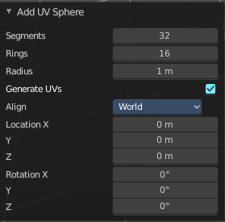
UV Sphere
UV Sphere creates a sphere mesh.

Last Operator Add UV Sphere Panel
Segments defines of how much segments the sphere has vertically.
Rings defines how much rings the sphere has horizontally.
Size defines the radius of the UV Sphere.
Generate UV's creates UV's for this primitive.
Align to view aligns the geometry to the chosen view. World, View or 3D cursor.
Note that this option is dysfunctional when you call the Adjust Last Operator panel from the Toolbar editor.
Location defines the location of the Sphere.
Rotation defines the rotation of the Sphere.

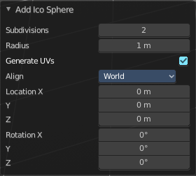
Ico Sphere
Ico Sphere creates a sphere mesh.

Last Operator Add Ico Sphere Panel
Subdivisions defines the subdivision level of the Ico Sphere.
Size defines the radius of the Ico Sphere.
Generate UV's creates UV's for this primitive.
Align to view aligns the geometry to the chosen view. World, View or 3D cursor.
Note that this option is dysfunctional when you call the Adjust Last Operator panel from the Toolbar editor.
Location defines the location of the Sphere.
Rotation defines the rotation of the Sphere.

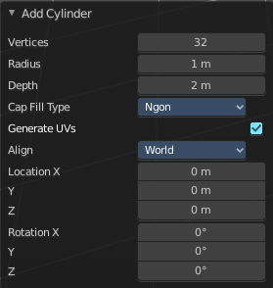
Cylinder
Cylinder creates a Cylinder mesh.

Last Operator Add Circle Panel
Vertices defines of how much vertices the circle is made.
Radius defines the radius of the Cylinder.
Depth defines the length of the Cylinder.
Cap Fill Type defines how the cap face is filled.
- Nothing means you have no face at the top and the bottom of the Cylinder.
- N-Gon means that the cap face is an N-Gon face.
- Triangle Fan means that the cap face is triangulated.
Generate UV's creates UV's for this primitive.
Align to view aligns the geometry to the chosen view. World, View or 3D cursor.
Note that this option is dysfunctional when you call the Adjust Last Operator panel from the Toolbar editor.
Location defines the location of the Cylinder.
Rotation defines the rotation of the Cylinder.

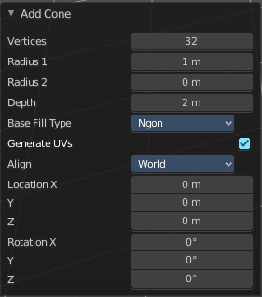
Cone
Cone creates a Cone mesh

Last Operator Add Cone Panel
Vertices defines of how much vertices the circle is made.
Radius 1 defines the base radius of the Cone.
Radius 2 defines the top radius of the Cone.
Depth defines the length of the Cone.
Base Fill Type defines how the Base face is filled.
- Nothing means you have no base face.
- N-Gon means that the base face is an N-Gon face.
- Triangle Fan means that the base face is triangulated.
Generate UV's creates UV's for this primitive.
Align to view aligns the geometry to the chosen view. World, View or 3D cursor.
Note that this option is dysfunctional when you call the Adjust Last Operator panel from the Toolbar editor.
Location defines the location of the Cone.
Rotation defines the rotation of the Cone.

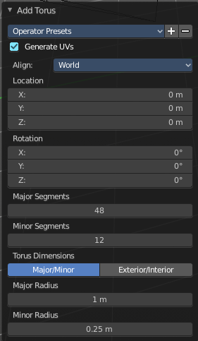
Torus
Torus creates a Torus mesh

Last Operator Add Torus Panel
Operator Presets allows you to store presets for the Torus. So that you don't have to start from scratch when you need different tori with different setup. This presets are temporary. And cannot be stored between sessions.
Align to view aligns the geometry to the chosen view. World, View or 3D cursor.
Note that this option is dysfunctional when you call the Adjust Last Operator panel from the Toolbar editor.
Location defines the location of the Torus.
Rotation defines the rotation of the Torus.
Major segments defines the segment division of the Torus.
Minor segments defines the circle division of the Torus.
Torus Dimensions defines the method to use when changing Major and Minor Radius.
Major Radius changes the radius of the Torus.
Minor Radius changes the thickness of the Torus.

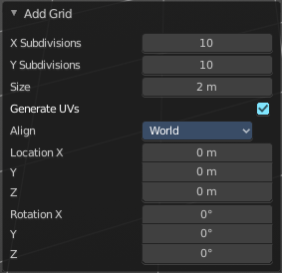
Grid
Grid creates a subidividable plane mesh

Last Operator Add Grid Panel
X Subdivisions defines the number of subdivisions in x direction.
X Subdivisions defines the number of subdivisions in Y direction.
Size is in real the size of the plane.
Generate UV's creates UV's for this primitive.
Align to view aligns the geometry to the chosen view. World, View or 3D cursor.
Note that this option is dysfunctional when you call the Adjust Last Operator panel from the Toolbar editor.
Location Adjust the location of the Plane.
Rotation defines the rotation of the Plane.

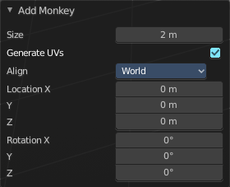
Monkey
Monkey creates a monkey head mesh.

Last Operator Add Monkey Panel
Radius is in real the size of the object.
Align to view aligns the geometry to the chosen view. World, View or 3D cursor.
Note that this option is dysfunctional when you call the Adjust Last Operator panel from the Toolbar editor.
Location Adjust the location of the Monkey head mesh.
Rotation defines the rotation of the Monkey head mesh.

Curve
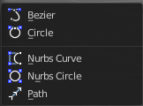
Add curves primitives.
Curve objects are mathematical curves that are defined by a start and endpoint. You can edit the shape of the curve by handlers. Curves have several purposes. They can be used as a path. Or you use them as the base for a mesh object.
The curve types are very similar. But do have some small differences. The difference between Bezier and Nurbs is that with Bezier you have handlers at the curve. And with a Nurbs you have a control geometry to influence the curve.
Note that Curves is no mesh data. You have to convert the Curves data to Mesh data when you want to work with it like with a mesh. Note also that you cannot convert it back to curve then.

Bezier
Bezier creates a Bezier type curve.

Circle
Circle creates a Bezier circle type curve.

Nurbs Curve
Nurbs Curve creates a Nurbs type curve.

Nurbs Circle
Nurbs Circle creates a Nurbs type circle curve.

Path
Path creates a Nurbs type curve.

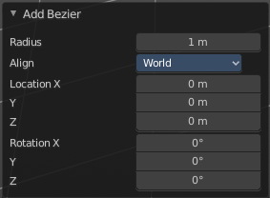
Last Operator Add Curve
The Last Operator add panel is for all curves equal.
Radius is in real the size of the object.
Align to view aligns the geometry to the chosen view. World, View or 3D cursor.
Note that this option is dysfunctional when you call the Adjust Last Operator panel from the Toolbar editor.
Location Adjust the location of the curve.
Rotation defines the rotation of the curve.

Surface
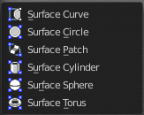
Surfaces are some kind of curves. But curves with which you can construct surfaces. Surfaces are all of type Nurbs curves.
Note that Surfaces similar to Curves is no mesh data. You have to convert the Surfaces data to Mesh data when you want to work with it like with a mesh. Note also that you cannot convert it back to Surface then.

Surface Curve
Surface Curve creates a Nurbs type curve.

Surface Circle
Surface Circle creates a Nurbs type circle.

Surface Surface
Surface Surface creates a Nurbs type Surface.

Surface Cylinder
Surface Cylinder creates a Nurbs type cylinder.

Surface Sphere
Surface Sphere creates a Nurbs type sphere.

Surface Torus
Surface Torus creates a Nurbs type Torus.

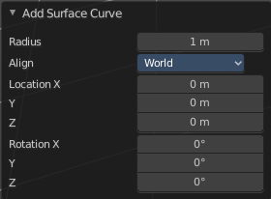
Last Operator Add Surface
The Last Operator add panel is for all curves equal.
Radius is in real the size of the object.
Align to view aligns the geometry to the chosen view. World, View or 3D cursor.
Note that this option is dysfunctional when you call the Adjust Last Operator panel from the Toolbar editor.
Location Adjust the location of the surface.
Rotation defines the rotation of the surface.

Metaball

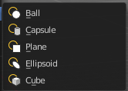
Meta-balls are procedural primitives. They are not defined by vertices or curves. The interesting behavior of meta-balls is that you can stick them into each other. And they have one surface then. Like merging two water drops. And this works in Object mode already.

Ball
Ball creates a meta-ball in Sphere shape.

Capsule
Capsule creates a meta-ball in Capsule shape.

Plane
Plane creates a meta-ball in Plane shape.

Ellipsoid
Ellipsoid creates a meta-ball in Ellipsoid shape.

Cube
Cube creates a meta-ball in Cube shape.

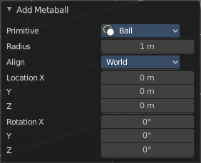
Last Operator Add Meta ball
The Last Operator add panel is for all Meta-balls equal.
Primitive is a drop-down box where you can change the Meta ball type.
Radius is in real the size of the object.
Align to view aligns the geometry to the chosen view. World, View or 3D cursor.
Note that this option is dysfunctional when you call the Adjust Last Operator panel from the Toolbar editor.
Location Adjust the location of the surface.
Rotation defines the rotation of the surface.

Text

Text creates a text object. With a text object you can create a text in the 3D viewport. Text is not mesh geometry. It is a special curve geometry. But you can convert it to a mesh. See Object menu, Convert to.
Text can be cut, copied and pasted in the usual way by ctrl x, ctrl c and ctrl v
There is a limit of characters, which is by 50.000.

Objects as Fonts
You can also “create” your own “font” inside Bforartists! This is quite a complex process, so let’s detail it:
- First, you must create your chars. Each char is an object of any type (mesh, curve, meta...). They all must have a name following the schema: common prefix followed by the char name (e.g. ft.a, ft.b, etc.).
- Then, for the Text object, you must enable the Dupli Verts button (Object context - Anim Settings panel).
- Back in Editing context, in the Font panel, fill the Ob Family field with the common prefix of your “font” objects.
Now, each time a char in your text matches the suffix part of a “font” object’s name, this object is duplicated on this char. The original chars remain visible. The objects are duplicated so that their center is positioned at the lower right corner of the corresponding chars.

Note
You can enter the Edit mode with the standard hotkey. But you cannot switch back to Object mode with the standard hotkey. Since this hotkey gets count as input for the text object in Edit mode. You have to use the mode drop-down box to leave the Edit mode.

Editing Text
Editing text is different from other object types in Bforartists. You edit on the one hand a curve type object, but also a text. And so the text editing standards applies. Like hitting backspace to delete parts of the text.

Inserting Text
You can type in new text. You can also copy text from a text editor and paste it. Or you can load a text file.
To load text from a text file, use the Edit / Paste File tool. This will bring up a File Browser window for navigating to a valid UTF-8 file.

Accent Characters

WARNING
Note that this feature is broken by Blender design. A Bug report to fix it was rejected.
The hotkey alone is a challenge. Press the keys in the wrong order and it will not work.
And not all UTF8 characters are supported. The default font just supports a fraction. This can partially be fixed by choosing another font. But the underlying code also just works for a fraction. It can be that not even the listed combinations in the manual here are working for you. There is a conflict with different keyboard layouts involved. And there is no documentation of further possible key combinations available.
When you want to work with special UTF8 characters, then we highly recommend to write this text in a text file and import this text file then.
You have been warned!

Many special characters can be “composed” using a combination of two other characters. The hotkey for it is the character followed by Alt-Backspace followed by the desired key to produce the accent character. Note that the following key combinations works with the US keyboard layout, even when you use the german keyboard layout.
Some examples.
ã - A, Alt-Backspace, ~
á - A, Alt-Backspace, '
à - A, Alt-Backspace, Backslash
â - A, Alt-Backspace, ^
å - A, Alt-Backspace, O
æ - A, Alt-Backspace, E
ª - A, Alt-Backspace, Minus
ë - E, Alt-Backspace, "
ç - C, Alt-Backspace, Comma
¢ - C, Alt-Backspace, |
ø - O, Alt-Backspace, Slash
§ - S, Alt-Backspace, S
† - |, Alt-Backspace, Minus
‡ - |, Alt-Backspace, =
© - O, Alt-Backspace, C
® - O, Alt-Backspace, R
™ - T, Alt-Backspace, M
½ - 1, Alt-Backspace, 2
÷ - Minus, Alt-Backspace, :
± - Minus, Alt-Backspace, Plus

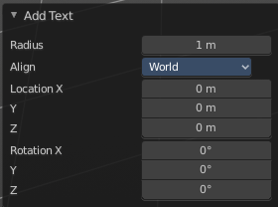
Last Operator Add Text
Radius is in real the size of the Text object.
Align to view aligns the geometry to the chosen view. World, View or 3D cursor.
Note that this option is dysfunctional when you call the Adjust Last Operator panel from the Toolbar editor.
Location Adjust the location of the Text object.
Rotation defines the rotation of the Text object.

You can navigate the cursor with the arrow buttons. Enter adds a new paragraph. When you use the navigator you will see a last operator Move Cursor with further options.

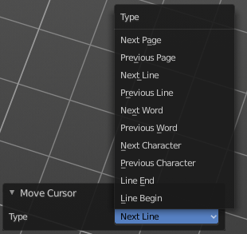
Last Operator Move Cursor

Type
The different methods to set the cursor.

Point Cloud

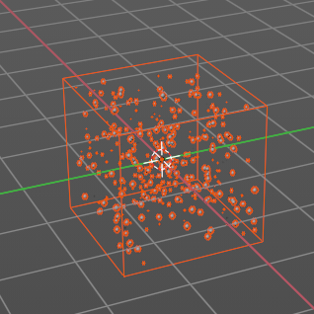
Creates a object of type Point Cloud. Point clouds can represent 3D scans. It is also planned to represent particles in the future. Each point can store data in a set of Attributes. The attributes can be found in the Properties Editor in the Object Data Properties.

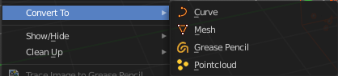
At the moment there is not this much that can be done with Point Clouds. But you can convert a object to a point cloud and vice versa.

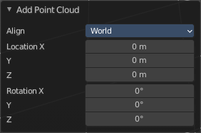
Last Operator Add Point Cloud

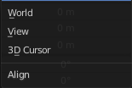
Align
How to orient the point cloud at creation.
Note that this option is dysfunctional when you call the Adjust Last Operator panel from the Toolbar editor.

Location X Y Z
The position of the point cloud at creation.

Rotation X Y Z
The rotation of the point cloud at creation.

Volume

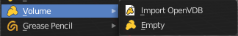
Add a volume object.

Import OpenVDB
Imports a volume object of type OpenVDB. This button opens a file browser.

Empty
Create an empty Volume object.

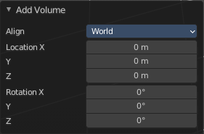
Last Operator Add Volume

Align
How to orient the point cloud at creation.
Note that this option is dysfunctional when you call the Adjust Last Operator panel from the Toolbar editor.

Location X Y Z
The position of the point cloud at creation.

Rotation X Y Z
The rotation of the point cloud at creation.

Grease Pencil

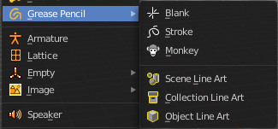
With a grease pencil object you can draw in the 3D viewport.
It starts as an object type. By switching into paint mode it becomes a paint feature. And editing turns it into a curve or a mesh object then.

It can be use to make traditional 2D animation, cut-out animation, motion graphics or use it as storyboard tool among other things.
You add a grease pencil object, switch to draw mode, choose the color or add a new one. And when done with drawing you can manipulate the grease pencil object in edit mode or in weight paint mode even further.
The colors are materials.
In the Tools tab you will find all the options and settings for drawing and manipulating the grease pencil object, means your drawing.

Blank
Adds a blank grease pencil object with just one black color and no geometry.

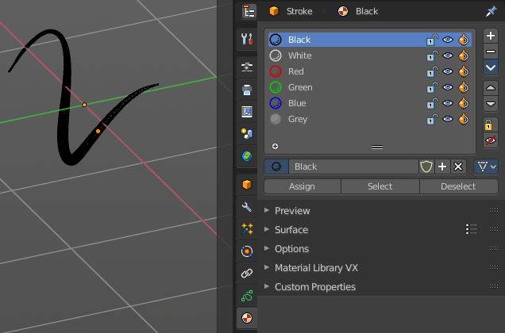
Stroke
Adds a grease pencil stroke with some predefined colors.

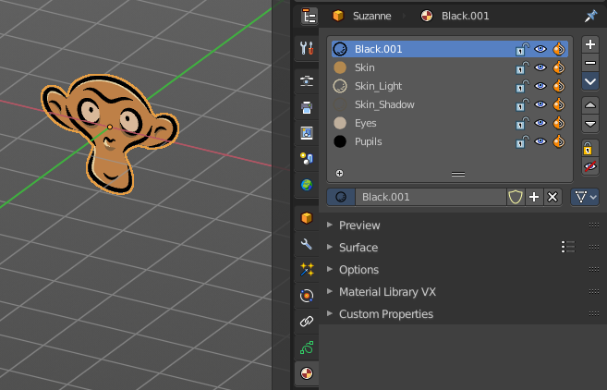
Monkey
Adds the drawing of a monkey as an example with some predefined colors.

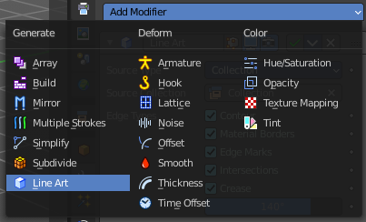
Scene Line Art
Line Art is a modifier for the grease pencil object. Scene Line Art adds a grease pencil object with the Line Art Modifer set up for the whole scene.

Collection Line Art
Line Art is a modifier for the grease pencil object. Scene Line Art adds a grease pencil object with the Line Art Modifer set up for a collection.

Object Line Art
This menu item just shows when you have a mesh object selected. Line Art is a modifier for the grease pencil object. Scene Line Art adds a grease pencil object with the Line Art Modifer set up for the selected mesh object.

Last Operator Add Grease Pencil
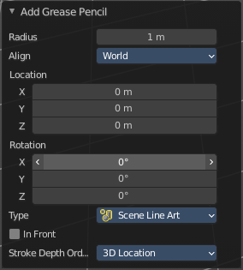
The Last Operator add Grease Pencil panel is for all grease pencil objects equal.
Radius is in real the size of the object.
Align aligns the geometry to the chosen view. World, View or 3D cursor.
Note that this option is dysfunctional when you call the Adjust Last Operator panel from the Toolbar editor.
Location Adjust the location of the surface.
Rotation defines the rotation of the surface.

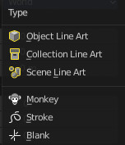
Type Choose the grease pencil type.
Line art types gives you further options.

In Front
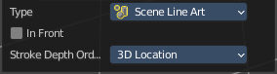
Show the grease pencil line art in front of everything.

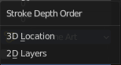
Stroke Depth Order
How to order the strokes.

Armature

Armature adds the first bone of a skeleton. This bone can be further extended in edit mode. And you can animate the created skeleton in pose mode.
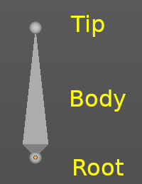
A bone has three elements. The start joint is called root or head. The body is called body. And the end joint is called tip or tail.

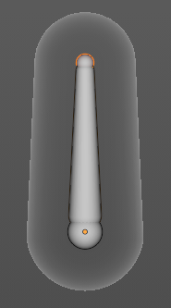
A bone can also have an influence area. The so called envelope.

The bones of an armature can be edited in Edit mode. And posed in Pose mode.

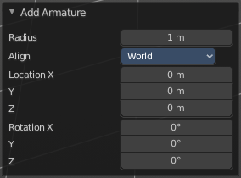
Last Operator Add Armature
Radius is in real the size of the Armature object.
Align aligns the geometry to the chosen view. World, View or 3D cursor.
Note that this option is dysfunctional when you call the Adjust Last Operator panel from the Toolbar editor.
Location Adjust the location of the Armature object.
Rotation defines the rotation of the Armature object.

Lattice

A lattice object is a control cage to control deforming at another object.

Usage
Create a Lattice object.
Make sure it is bigger than the object that you want to deform, and is around this object.
Add a Lattice Modifier to the object that you want to deform.
In the Object box of the Lattice Modifier add our created Lattice object.
Select Lattice Object. Enter Edit mode. And here you can deform the Lattice Object now, and the object to deform will follow.

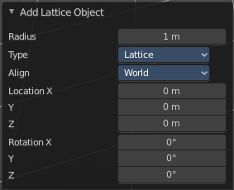
Last Operator Add Lattice object
Radius is in real the size of the Lattice object.
Type is a drop-down box choose any other object type to create.
Align aligns the geometry to the chosen view. World, View or 3D cursor.
Note that this option is dysfunctional when you call the Adjust Last Operator panel from the Toolbar editor.
Location Adjust the location of the Lattice object.
Rotation defines the rotation of the Lattice object.

Empty

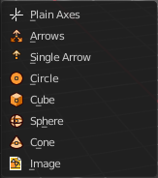
An Empty is an object without any data attached. It is basically just a container. It is empty. Empties can be used as anchor objects. Or as visible handlers at a skeleton for example.
The empty types differs just by how they gets displayed in the viewport.

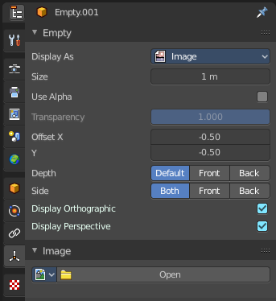
The empty of type image allows you to load an image to display the empty. This image can be adjusted and loaded in the object data panel of the empty object.
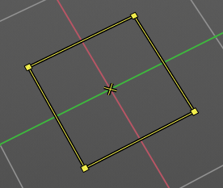
The image empty has also a transform widget, presented by the yellow color. It becomes visible when you hover with the mouse over the object.
Empties, no matter what shape, does not render to file.

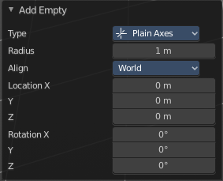
Last Operator Add Empty
Type is a drop-down box where you can define the type of Empty object.
Radius is in real the size of the Empty object.
Align aligns the geometry to the chosen view. World, View or 3D cursor.
Note that this option is dysfunctional when you call the Adjust Last Operator panel from the Toolbar editor.
Location Adjust the location of the Empty object.
Rotation defines the rotation of the Empty object.

Image
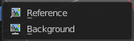
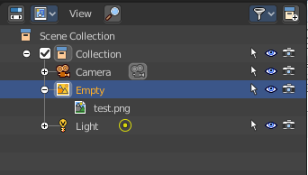
Image objects allows you to import and display images in the viewport. Image objects are nothing else than Empties of type Image. So in the outliner they will show up as empties.
When you create an image object, then the file browser opens, choose the image that you want to use as the reference image. It loads with the correct ratio.

Neither reference images nor background images does render to file. They are just meant to display images in the viewport.

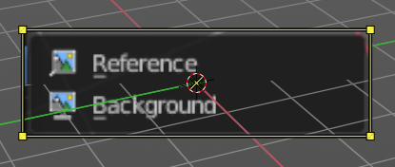
Reference
A reference image is for example used to model along the shape of a car at an image.

The image has also a transform widget, presented by the yellow color. It becomes visible when you hover with the mouse over the object.
Important, the reference image loads oriented in the current screen orientation. So when you need the image in the side view, then you should be in the side view when you create a reference image.
This image can be adjusted and changed in the object data panel of the object. Don't wonder about the panel name, which is Empty. As told above, the reference image is in fact nothing else than a special form of the image empty.

Background
Background images are meant to display images in the background of the viewport, while rendering.
There is just one difference between a Reference and a Background image.
A reference image is double sided. A background image not. When you look from the back side, then it is transparent.

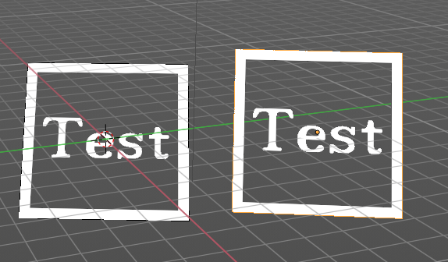
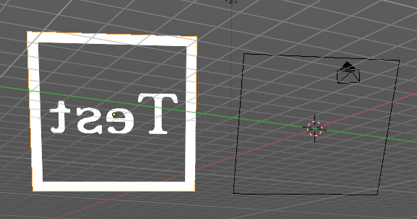

Speaker

A speaker object allows you to add a sound source to the scene. This can be used in a movie for example.

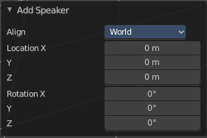
Last Operator Add Speaker
Align aligns the geometry to the chosen view. World, View or 3D cursor.
Note that this option is dysfunctional when you call the Adjust Last Operator panel from the Toolbar editor.
Location Adjust the location of the Speaker object.
Rotation defines the rotation of the Speaker object.

Camera

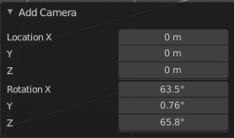
A camera object allows you to render your scene.
Camera objects can be further adjusted in the properties editor.

Last Operator Add Camera
Location Adjust the location of the Camera object.
Rotation defines the rotation of the Camera object.

Light

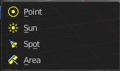
Lights lights the scene.

The lights that you add here lights the rendered scene. Not the scene in the viewport. Viewport lighting is managed in the viewport shading panel.

Lights can be further adjusted in the properties editor.

Point
Point creates a Point Light. A point light shines into all directions.

Sun
Sun creates a light that behaves like a sun. It's a directional light.

Spot
Spot creates a Spot light. It's a directional light.

Area
Area creates an Area light. It's a directional light.

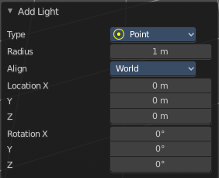
Last Operator Add Light
The Last Operator add panel is for all lights equal.
Type is a drop-down box where you can change the light type.
Radius is in real the size of the lamp.
Align aligns the geometry to the chosen view. World, View or 3D cursor.
Note that this option is dysfunctional when you call the Adjust Last Operator panel from the Toolbar editor.
Location Adjust the location of the object.
Rotation defines the rotation of the object.

Light Probe
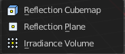
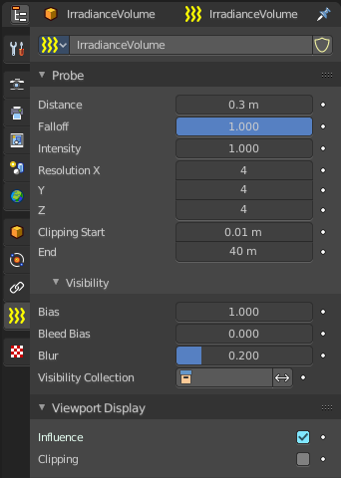
Light Probe objects are used by the Eevee render engine as support objects. They precompute lighting information locally in order to light the scene using indirect lighting. Which speeds things up.
There are three different light probe types. One for diffuse light lighting, two for specular lighting.
Light probes are a feature for real time render engines. This means Light probes does not work for the other renderers in Bforartists. Just in Eeevee.
The light probes can be further adjusted in the Properties Editor.

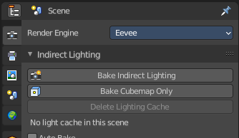
To work with the light probes you need to bake them. Baking lightpropbes happens in the render properties tab in the indirect lighting panel.

Reflection Cubemap
Adds a reflective light probe in cubemap shape.

Reflection Plane
Adds a reflective light probe in plane shape.

Irradiance Volume
Adds a volumetric array light probe.

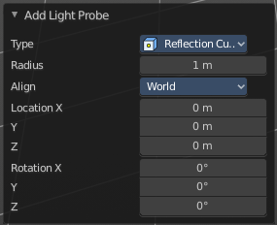
Last Operator Add Light Probe
The Last Operator add panel is for all light probes equal.
Type is a drop-down box where you can change the light type.
Radius is in real the size of the light probe.
Align aligns the geometry to the chosen view. World, View or 3D cursor.
Note that this option is dysfunctional when you call the Adjust Last Operator panel from the Toolbar editor.
Location Adjust the location of the object.
Rotation defines the rotation of the object.

Force Field
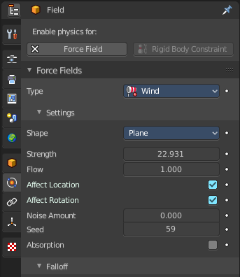
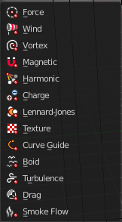
A Force Field is for physical simulations. It provides you with tools to add different forces to objects. Wind, Smoke, Gravity, Magnetic, etc. .

The added Force Fields can be further adjusted in the Properties panel.

A Force Field is internally also called Effector. So our Last Operator panel has the title Add Effector.

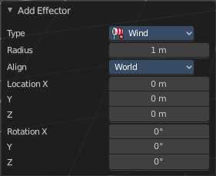
Last Operator Add Effector
Type is a drop-down box where you can define the type of Effector.
Radius is in real the size of the Effector.
Align aligns the geometry to the chosen view. World, View or 3D cursor.
Note that this option is dysfunctional when you call the Adjust Last Operator panel from the Toolbar editor.
Location Adjust the location of the Effector.
Rotation defines the rotation of the Effector.

Collection Instance
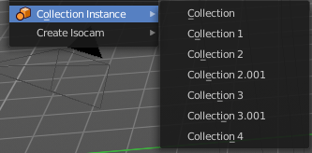
Add an instance of an existing collection. By default it is just one. But the menu lists all available collections in the scene.

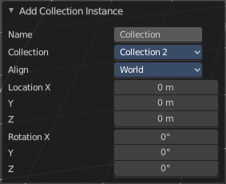
Last Operator Add Collection Instance
Name Name your new collection.
Radius A drop down box choose the collection.
Align aligns the geometry to the chosen view. World, View or 3D cursor.
Note that this option is dysfunctional when you call the Adjust Last Operator panel from the Toolbar editor.
Location Adjust the location of the collection.
Rotation defines the rotation of the collection.

Create Isocam

The add menu is also a common menu where addons adds their entries. Create Isocam is such an add-on. It comes with Bforartists, and is activated by default.

Create Isocam is a script that creates an orthographic camera with which you can render isometric views for 2d isometric games. You can of course set the whole thing up by hand. This script saves you the work though.

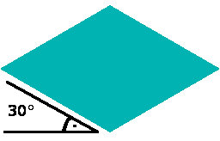
True Isocam
Creates a camera that has the mathematical isometric angles compared to the ground plane.
The camera has a rotation of 54.736 degrees.

Game Isocam

Creates a camera that has the isometric angles for a 2d isometric game. This angle differs a bit from the mathematical angle. With the mathematical angle we would get some not fitting stairs.

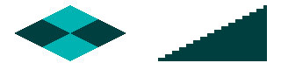
With the angle of 60 degrees for the camera we get a fitting result for an isometric game tile with the common 2:1 ratio.

GameIso4to3cam

There is another special view that fits together like the one with the 2:1 ratio . Here we don’t have a base tile of 64×32 and a ratio of 2:1, but one with 64×48 and a ratio of 4:3. It is of course not a power of two graphics anymore. And far away from the true isometric view. But the old graphics card limits are long gone. And when you need a more top down view, then this is perfect.
For that the camera has a rotation of 41.5 Grad.

Ground plane
Adds a ground plane that fits into the camera view of the iso cams.

